Cross-quantilogram: AUDUSD and USDCHF
Method 20 / daily log returns / expanding quantiles / Alpari D1 full available history

Study setup
Logical pair: AUDUSD , USDCHF
Broker symbols: AUDUSD_i , USDCHF_i
Snapshot: 2026-11-03_majors_alpari_D1
Timeframe: D1
Matched return window: 1999-01-05 to 2026-11-02 (UTC bar dates)
Matched return count n: 7200
Dropped unfinished last bar dated 2026-11-03 UTC after a tick-volume check against the prior complete day.
Quantiles: expanding window, min history 252 days
tau in [0.05, 0.2]; k=0..10; headline tau=0.05, k=1
Complete matched rows (Excel): AUDUSD-USDCHF_CQ_D1.xlsx
Complete matched rows (HTML table): AUDUSD-USDCHF_CQ_D1_data.html

Method carried forward
The cross-quantilogram rho_tau(k) measures linkage among centered quantile-hit indicators of matched daily log returns of close, ln(close_t / close_t-1). Quotes are not inverted. At each date t, the tau-quantile uses only returns through t (expanding window) after a minimum history of 252 days. Hits are h_t = 1(r_t < q_t) - tau. rho_tau(k) is the normalized cross-product of h_x,t with h_y,t+k. Levels tau in {0.05, 0.20} and lags k=0..10 are pre-specified; headline is tau=0.05, k=1 both directions. Same-sample Pearson r is a side check. This is not causation and not a trading signal.

Results (headline)
rho_AUDUSD->USDCHF(tau=0.05,k=1): 0.006336
rho_USDCHF->AUDUSD(tau=0.05,k=1): 0.044276
rho_AUDUSD->USDCHF(tau=0.20,k=1): 0.006389
rho_USDCHF->AUDUSD(tau=0.20,k=1): 0.035114
Pearson r: -0.380878

CQ table (tau=0.05)
k | rho_AUDUSD_to_USDCHF | n_AUDUSD_to_USDCHF | rho_USDCHF_to_AUDUSD | n_USDCHF_to_AUDUSD
0 | -0.00883036 | 6949 | -0.00883036 | 6949
1 | 0.00633592 | 6948 | 0.04427555 | 6948
2 | 0.03667849 | 6947 | 0.03667849 | 6947
3 | 0.02528725 | 6946 | 0.0518455 | 6946
4 | 0.02907208 | 6945 | 0.02148393 | 6945
5 | 0.01388644 | 6944 | 0.05182753 | 6944
6 | 0.03664196 | 6943 | 0.05181854 | 6943
7 | 0.02549076 | 6942 | 0.02525028 | 6942
8 | 0.05209403 | 6941 | 0.02524104 | 6941
9 | 0.05208503 | 6940 | 0.02523179 | 6940
10 | 0.04827416 | 6939 | 0.04039971 | 6939

Conclusion
Headline tau=0.05, k=1 for AUDUSD and USDCHF: rho_AUDUSD->USDCHF = 0.0063; rho_USDCHF->AUDUSD = 0.0443. At tau=0.20, k=1: 0.0064 and 0.0351. Same-day tau=0.05 rho(k=0) = -0.0088. Pearson r = -0.3809. This is quantile-hit linkage, not a trading signal.

Charts
Daily closes

Daily log returns

Cross-quantilogram tau=0.05
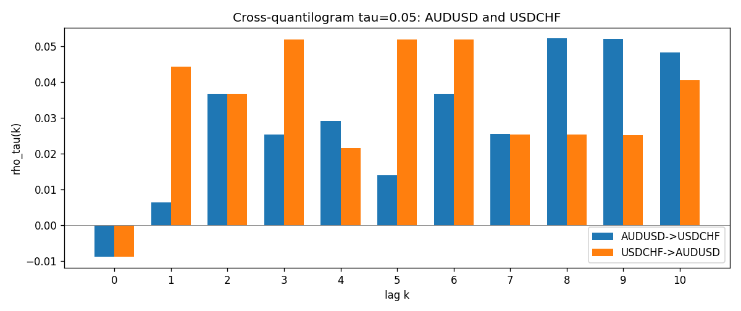

Data report
Matched rows and the CQ sheet are in the sibling Excel workbook named AUDUSD-USDCHF_CQ_D1.xlsx. Embedding all rows as a Word table is impractical; this file holds column summaries and the first and last 15 matched rows.
Columns: time, AUDUSD_open, USDCHF_open, AUDUSD_high, USDCHF_high, AUDUSD_low, USDCHF_low, AUDUSD_close, USDCHF_close, AUDUSD_tick_volume, USDCHF_tick_volume, AUDUSD_spread, USDCHF_spread, AUDUSD_real_volume, USDCHF_real_volume, AUDUSD_log_return, USDCHF_log_return, AUDUSD_h_t005, USDCHF_h_t005
Column summaries (matched calculation rows)
column | count | mean | std | min | 25% | 50% | 75% | max
AUDUSD_open | 7200 | 0.7519587 | 0.13528421 | 0.4785 | 0.6610975 | 0.731415 | 0.8091275 | 1.10284
USDCHF_open | 7200 | 1.0982244 | 0.25258622 | 0.72022 | 0.920675 | 0.990175 | 1.238625 | 1.8219
AUDUSD_high | 7200 | 0.75601148 | 0.13584385 | 0.4878 | 0.6647 | 0.734785 | 0.8152525 | 1.10795
USDCHF_high | 7200 | 1.1035234 | 0.25433538 | 0.73305 | 0.9249475 | 0.99377 | 1.2436 | 1.8313
AUDUSD_low | 7200 | 0.74790307 | 0.1345988 | 0.4775 | 0.65778 | 0.727495 | 0.804225 | 1.0975
USDCHF_low | 7200 | 1.0930985 | 0.25099871 | 0.08565 | 0.917415 | 0.98668 | 1.232725 | 1.8121
AUDUSD_close | 7200 | 0.75201172 | 0.13526687 | 0.4786 | 0.6612 | 0.731695 | 0.8091975 | 1.10169
USDCHF_close | 7200 | 1.0982149 | 0.25248642 | 0.72025 | 0.92097 | 0.990145 | 1.238625 | 1.8217
AUDUSD_tick_volume | 7200 | 77358.386 | 138142.18 | 109 | 5440 | 43334.5 | 71332.25 | 1234623
USDCHF_tick_volume | 7200 | 74199.562 | 113414.45 | 350 | 12776 | 40195 | 70261.25 | 858589
AUDUSD_spread | 7200 | 30.817222 | 16.887144 | 0 | 13 | 30 | 50 | 50
USDCHF_spread | 7200 | 26.104306 | 24.710129 | 0 | 5 | 16 | 50 | 100
AUDUSD_real_volume | 7200 | 5.2428187e+09 | 1.2538918e+11 | 0 | 0 | 0 | 0 | 3.811512e+12
USDCHF_real_volume | 7200 | 2.3239785e+10 | 8.9047261e+10 | 0 | 0 | 0 | 0 | 1.9331921e+12
AUDUSD_log_return | 7200 | 2.837e-05 | 0.00754598 | -0.08602525 | -0.00385535 | 0.0002835 | 0.00415437 | 0.0806166
USDCHF_log_return | 7200 | -7.168e-05 | 0.00659376 | -0.19545699 | -0.00336083 | 8.057e-05 | 0.00331954 | 0.09051364
AUDUSD_h_t005 | 6949 | -0.0036624 | 0.21023032 | -0.05 | -0.05 | -0.05 | -0.05 | 0.95
USDCHF_h_t005 | 6949 | -0.0166139 | 0.17965554 | -0.05 | -0.05 | -0.05 | -0.05 | 0.95
First 15 matched rows (selected columns)
time | AUDUSD_log_return | USDCHF_log_return | AUDUSD_h_t005 | USDCHF_h_t005
1999-01-05 | -0.00080418179 | 0.0039424743 | nan | nan
1999-01-06 | 0.011836351 | 0.013605652 | nan | nan
1999-01-07 | 0.0088650256 | -0.0093883841 | nan | nan
1999-01-08 | 0.00031515916 | 0.011040268 | nan | nan
1999-01-11 | 0.0072213815 | 0.0052963193 | nan | nan
1999-01-12 | -0.0048608485 | -0.0098275602 | nan | nan
1999-01-13 | -0.0078902098 | -0.018259701 | nan | nan
1999-01-14 | -0.002696916 | -0.0024256692 | nan | nan
1999-01-15 | 0.007123101 | 0.01794228 | nan | nan
1999-01-18 | 0.00094592471 | -0.0031856384 | nan | nan
1999-01-19 | 0.0072225153 | -7.2518946e-05 | nan | nan
1999-01-20 | 0.0012507819 | 0.0072259871 | nan | nan
1999-01-21 | 0.00078094498 | -0.0038232689 | nan | nan
1999-01-22 | -0.012252745 | -0.0001445609 | nan | nan
1999-01-25 | -0.0039591468 | 0.0024546976 | nan | nan
Last 15 matched rows (selected columns)
time | AUDUSD_log_return | USDCHF_log_return | AUDUSD_h_t005 | USDCHF_h_t005
2026-10-13 | 0.0035007712 | -0.0024955621 | -0.05 | -0.05
2026-10-14 | -0.0015193215 | 0.0029388325 | -0.05 | -0.05
2026-10-15 | -0.0075447063 | -0.0097855323 | -0.05 | -0.05
2026-10-16 | 0.0033906408 | -0.0036230826 | -0.05 | -0.05
2026-10-19 | 0.0050859986 | 0.0036351779 | -0.05 | -0.05
2026-10-20 | 0.0034620426 | -0.0026281224 | -0.05 | -0.05
2026-10-21 | 0.0036066384 | -0.00040027413 | -0.05 | -0.05
2026-10-22 | -0.0012672558 | -0.0048036381 | -0.05 | -0.05
2026-10-23 | 0.0023765656 | 0.005652514 | -0.05 | -0.05
2026-10-26 | -0.0032032829 | 0.0018407959 | -0.05 | -0.05
2026-10-27 | 0.0016669876 | 0.0026100526 | -0.05 | -0.05
2026-10-28 | 0.0040915541 | -0.0010142111 | -0.05 | -0.05
2026-10-29 | -0.0040915541 | -0.0048680164 | -0.05 | -0.05
2026-10-30 | 0.0010102376 | 0.00071594559 | -0.05 | -0.05
2026-11-02 | -0.0049184984 | -0.0071459744 | -0.05 | -0.05

